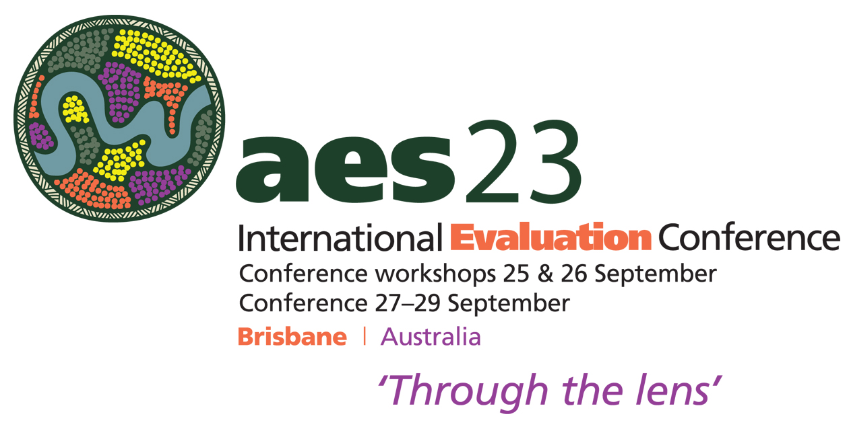

Conference workshop proposal template
25 and 26 September 2023

1. Abstract title (maximum of 200 characters):
Use sentence case. That is – capital letter for first word, proper nouns, and first word after a colon. For example, Evaluation resources: Tips for using NVivo software.

2. Workshop category: For details see conference website.

Please delete the categories which are not appropriate.
A. Foundational evaluation skills and capabilities
B. New tools; approaches and ways of thinking for a transforming context
C. Advanced evaluation topics

2. Presenter information

Please provide the following information for each presenter:
Given name, Surname; Institution, City, Country ¹

For example:

¹Bill Smith; Hillside College; Sydney, Australia

²Susan T. Jones; Hillside College; Sydney, Australia

³Jane Brown; International Consulting; London, United Kingdom

3. Abstract (maximum of 300 words)
Please familiarise yourself with the guidelines for conference workshop proposals listed on the conference website.

4. Justification statement (maximum of 300 words) (mandatory)
Please familiarise yourself with the guidelines for conference workshop proposals listed on the conference website.
Do not simply repeat what you have written in the abstract. This statement is for the reviewers only and will not be included in the conference booklet.

